

otlob

DATABASE PROJECT



GROUP 19

Kareem abed 180973

ABDULRHMAN ZAKARIA 186883

YOUSEF ADEL 188743

OMAR MOHAMED 190008

MOSTAFA HOSSAM 190905

**Contribution**

|  |  |
| --- | --- |
| KAREEM ABED | Schema: Order – Order Summary - Employee - Employee Address –Equipment -– Coding: Order Customer Payment Employee |
| Abdulrhman Zakaria | Schema: uses - Finance - department– Coding: Order Employee Restaurant Advertisement |
| Youssef Adel | Schema: Advertisement – Restaurant – Menu – Coding: Employee Order Restaurant Menu |
| Mostafa Hossam | Schema: Customer – Customer Address -Coding: Employee Department Equipment Finance |
| Omar Mohamed | Schema Customer Credit Card – Payment --Coding: Customer Payment Order Restaurant |

**Scope**

Otlob is an Egyptian food ordering app and website. It contains hundreds of restaurants that can be ordered from. Offers the quickest, easiest, most reliable food ordering experience. Shows the user all available restaurants near him and shows best offers and deals.

**Functionality**

The database needs to be created in order to keep track of the employees who are working for the company and to be able to track the orders made by which customer and who was it delivered by. Also to keep updated which restaurants are available and their advertisements.

**Description**

Otlob has employees that must work in one department, and each department has many employees, each department has a manager and each manager can only manage one department. Each employee has access to many equipment such as motorcycles and food boxes, and this equipment can be used by more than one employee. The drivers can take many orders to deliver, but the order can only be delivered by one driver. The customer can place many orders, but the order can only be requested by a single user. The customer can pay for multiple orders at the same time, but the order is paid for by a single customer. The order is cooked by one restaurant, while the restaurant can cook many orders at once. Each restaurant must have a menu and each menu belongs to one restaurant. Each restaurant can have many advertisements, but each advertisement belongs to a single restaurant.

**ERD** 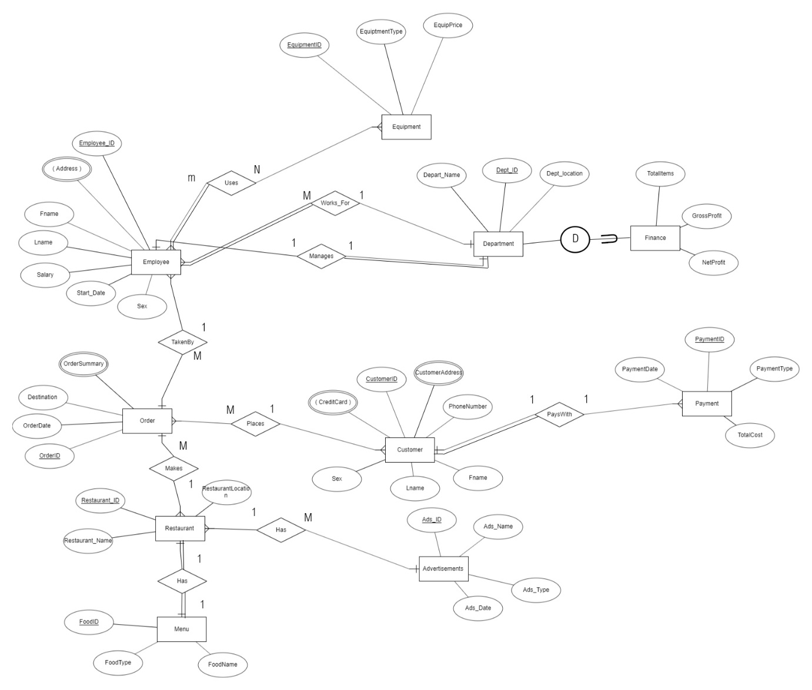

**Schema** 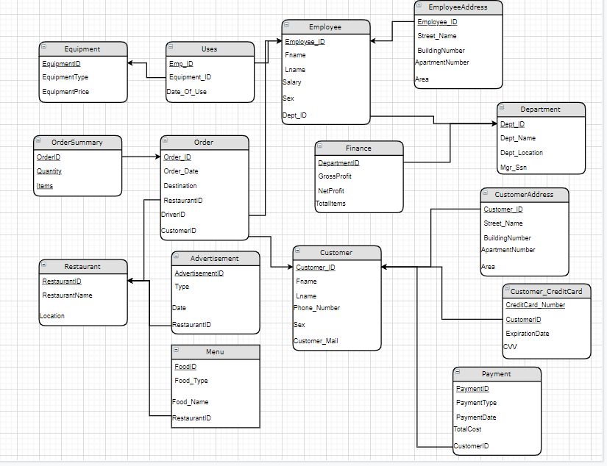

**CODE**

**1 – Kareem Abed**

/*Trigger */

Create Database Otlob2;

Create Table Employee(

Employee_ID INT NOT NULL,

Fname VARCHAR(20) NOT NULL,

Lname VARCHAR(20) NOT NULL,

Bdate VARCHAR(10),

Sex CHAR,

Salary INT NOT NULL,

Dno INT NOT NULL,

Constraint EmpPK Primary Key (Employee_ID),

);

Create Table EmployeeAddress(

EmployeeID int NOT NULL,

Street_Name Varchar(20),

BuildingNumber INT,

ApartmentNumber INT,

Constraint EmpAddressPK Primary Key (EmployeeID , ApartmentNumber),

CONSTRAINT EmpAddressFK FOREIGN KEY (EmployeeID) REFERENCES Employee (Employee_ID),

);

Create Table Customer(

Customer_ID Int Not Null,

Fname VARCHAR(20) NOT NULL,

Lname VARCHAR(20) NOT NULL,

PhoneNumber Int Not NUll,

CustomerEmail VARCHAR(50) Not NUll,

Sex CHAR,

Constraint CustomerPK Primary Key (Customer_ID),

);

Create Table CustomerCreditCard(

CustomerID int NOT NULL,

Credit_Card_Number INT NOT NULL,

Expiration_Date DATE,

CCV INT,

CONSTRAINT CustomerCC_PK PRIMARY KEY (CustomerID, Credit_Card_Number),

CONSTRAINT CustomerCC_FK FOREIGN KEY (CustomerID) REFERENCES Customer (Customer_ID),

);

Create Table CustomerAddress(

CustomerID int NOT NULL,

Street_Name Varchar(20),

BuildingNumber INT,

ApartmentNumber INT,

Constraint Cust_AddressPK Primary Key (CustomerID , ApartmentNumber),

CONSTRAINT Cust_AddressFK FOREIGN KEY (CustomerID) REFERENCES Customer (Customer_ID),

);

Create Table Orders(

OrderId Int Not Null,

OrderDate Date,

OrderDestination Varchar(20) NOT NULL,

EmployeeID INT,

CustomerID INT,

Constraint OrderPK Primary Key (OrderId),

Constraint EmpFK Foreign Key (EmployeeID) References Employee (Employee_ID),

Constraint CustomerFK Foreign Key (CustomerID) References Customer (Customer_ID),

);

Create Table Payment(

PaymentID int NOT NULL,

PaymentType varchar(20) Not Null,

TotalCost int,

PaymentDate Date,

CustomerID int,

Constraint PaymentPK Primary Key (PaymentID),

Constraint CustomerPaymentFK Foreign Key (CustomerID) References Customer (Customer_ID),

);

Create Table OrderSummary(

OrderID int NOT NULL,

Quantity int,

Items Varchar(30),

Constraint OrderSummaryPK Primary Key (OrderID , Quantity, Items),

Constraint SummaryFK Foreign Key (OrderID) References Orders (OrderId),

);

Alter Table EmployeeAddress

add Area Varchar(20);

Alter Table CustomerAddress

add Area Varchar(20);

Alter Table CustomerCreditCard DROP CONSTRAINT CustomerCC_PK;

Alter Table CustomerCreditCard Alter Column Credit_Card_Number varchar(30) NOT NULL;

Alter Table CustomerCreditCard Add Constraint CustomerCC_PK PRIMARY KEY (CustomerID, Credit_Card_Number);

INSERT INTO Employee Values (101, 'Kareem','Abed','26/5/1990', 'M', 50000, 01);

INSERT INTO Employee Values (102, 'Adham','Selim','14/1/1995', 'M', 10000, 01);

INSERT INTO Employee Values (103, 'Ahmed','Yasser','6/11/1994', 'M', 25000, 02);

INSERT INTO Employee Values (104, 'Saif','Haitham','15/9/1998', '', 15000, 01);

INSERT INTO Employee Values (105, 'Youssed','Ahmed','8/4/1991', 'M', 40000, 02);

INSERT INTO Employee Values (106, 'Hussein','Khaled','', 'M', 10000, 01);

INSERT INTO EmployeeAddress Values (101,'Omar Ibn Al Khattab',14,22,'Rehab' );

INSERT INTO EmployeeAddress Values (101,'Abbas el Akkad',98,31,'Nasr City' );

INSERT INTO EmployeeAddress Values (102,'Ibrahim El Orabi',19,11,'Nozha' );

INSERT INTO EmployeeAddress Values (102,'El Zohour',180,21,'Mohandessin' );

INSERT INTO EmployeeAddress Values (103,'Ibrahim El Orabi',19,11,'El Nozha' );

INSERT INTO EmployeeAddress Values (104,'Omar Ibn Al Khattab',185,32,'Almaza' );

INSERT INTO EmployeeAddress Values (105,'Omar Ibn Al Khattab',14,32,'Rehab' );

INSERT INTO EmployeeAddress Values (106,'Abbas el Akkad',190,21,'Nasr City' );

INSERT INTO Customer Values (201, 'Mohamed','Sherif',01297887991,'Mohamed@gmail.com','M');

INSERT INTO Customer Values (202, 'Youssed','Zayed',01231556095,'Youssed@gmail.com','');

INSERT INTO Customer Values (203, 'Zeyad','Ossama',01182773974,'Zeyad@yahoo.com','M');

INSERT INTO Customer Values (204, 'Adham','Megahed',01251667032,'Adham@gmail.com','M');

INSERT INTO Customer Values (205, 'Kareem','Mohamed',01997887991,'Kareem@gmail.com','M');

INSERT INTO CustomerAddress Values (201,'Othman Ibn Affan',91,32,'Rehab' );

INSERT INTO CustomerAddress Values (201,'Ibrahim El Orabi',150,31,'El Nozha' );

INSERT INTO CustomerAddress Values (202,'Ibrahim El Orabi',85,12,'El Nozha' );

INSERT INTO CustomerAddress Values (202,'Omar Ibn Al Khattab',14,31,'Rehab' );

INSERT INTO CustomerAddress Values (203,'Abbas El Akkad',99,41,'Nasr City' );

INSERT INTO CustomerAddress Values (204,'Omar Ibn Al Khattab',185,32,'Almaza' );

INSERT INTO CustomerAddress Values (205,'Othamn Ibn Affan',91,32,'Rehab' );

INSERT INTO CustomerAddress Values (205,'Abbas el Akkad',44,42,'Nasr City' );

INSERT INTO CustomerCreditCard Values (201,'4645796860481833','12/10/2019', 994);

INSERT INTO CustomerCreditCard Values (201,'4447096704314138','8/7/2023', 288);

INSERT INTO CustomerCreditCard Values (202,'4395333439185703','1/2/2022', 249);

INSERT INTO CustomerCreditCard Values (203,'4089549995429567','3/9/2024', 547);

INSERT INTO CustomerCreditCard Values (205,'4418234865335304','12/12/2019', 980);

INSERT INTO CustomerCreditCard Values (205,'4230030470020950','1/4/2022', 360);

INSERT INTO CustomerCreditCard Values (205,'4955314796464335','', 780);

INSERT INTO Orders Values (4366 , '2/11/2019' , 'Rehab' , 101 , 201);

INSERT INTO Orders Values (5416 , '11/11/2019' , 'Nasr City' , 101 , 203);

INSERT INTO Orders Values (9185 , '2/11/2019' , 'El Nozha' , 102 , 202);

INSERT INTO Orders Values (8871 , '10/5/2019' , 'Rehab' , 104 , 205);

INSERT INTO Orders Values (1010 , '2/11/2019' , 'Almaza' , 104 , 204);

INSERT INTO OrderSummary Values (4366 , 5 , 'McRoyale');

INSERT INTO OrderSummary Values (4366 , 1 , 'Milkshake');

INSERT INTO OrderSummary Values (4366 , 2 , 'Big Tasty');

INSERT INTO OrderSummary Values (5416 , 1 , 'King Mo Offer');

INSERT INTO OrderSummary Values (9185 , 2 , 'Chichken Ranch');

INSERT INTO OrderSummary Values (9185 , 1 , 'Chicken BBQ');

INSERT INTO OrderSummary Values (1010 , 1 , 'Big Mac');

INSERT INTO Payment Values (5159 , 'Cash' , 119 ,'2/11/2019' ,204);

INSERT INTO Payment Values (6078 , 'Credit Card' , 180 ,'2/11/2019' ,201);

INSERT INTO Payment Values (1151 , 'Cash' , 75 ,'2/11/2019' ,201);

INSERT INTO Payment Values (5431 , 'Credit Card' , 240 , '10/5/2019' ,205);

INSERT INTO Payment Values (0934 , 'Cash' , 100 ,'2/11/2019',202);

/* Drivers who delivered more than 1 order */

select Fname , Lname, count(EmployeeID) AS 'Number of Deliveries'

from Employee , Orders

Where Employee_ID = EmployeeID

Group By Fname , Lname

Having COUNT(EmployeeID) > 1;

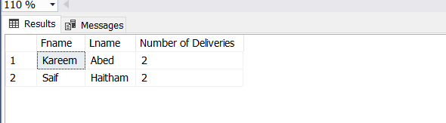

/*Customers Who Have Credit Cards */

select Fname , Lname , PhoneNumber

from Customer

Where Exists ( select *

from CustomerCreditCard

Where Customer_ID = CustomerID) ;

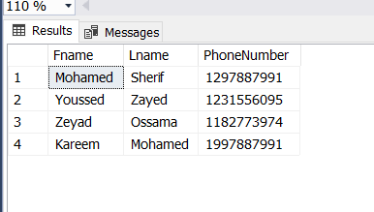

/*Max Salary of Driver who delivered to Rehab*/

Select MAX(Salary) AS 'Salary'

from Employee

Where Employee_ID IN ( select EmployeeID

from Orders

WHERE Employee_ID = EmployeeID AND OrderDestination = 'Rehab' );

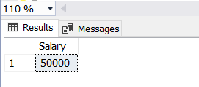

/*Shows customers and their credit card number(s) if available*/

select Fname , Lname , Customer_ID, Expiration_Date , Credit_Card_Number

from Customer left outer join CustomerCreditCard

ON Customer.Customer_ID = CustomerCreditCard.CustomerID;

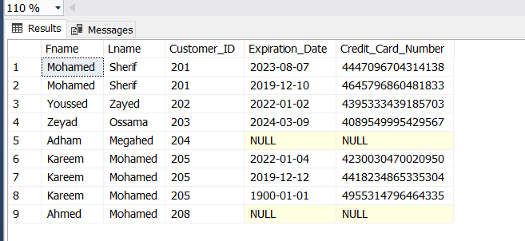

/*Got the order summary of the customer with a yahoo email */

select OrderID , Items , Quantity

from OrderSummary

where OrderID IN ( select OrderId

from Orders

where CustomerID IN (select Customer_ID

from Customer

where CustomerEmail like '%yahoo.com'));

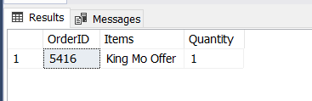

/* Tirgger */

Create Table Auditing(

Customer_ID INT,

FName VARCHAR(20),

LName VARCHAR(20),

PhoneNumber INT,

CustomerEmail varchar(50),

Sex char,

Audit_msg VARCHAR(50),

Audit_date Date

);

GO

CREATE TRIGGER Trig

ON Customer

AFTER INSERT

AS

declare @Customer_ID INT;

declare @Fname VARCHAR(20);

declare @Lname VARCHAR(20);

declare @PhoneNumber INT;

declare @CustomerEmail VARCHAR(50);

declare @Sex Char;

declare @paudit VARCHAR(50);

select @Customer_ID = i.Customer_ID from inserted i;

select @Fname = i.Fname from inserted i;

select @Lname = i.Lname from inserted i;

select @PhoneNumber = i.PhoneNumber from inserted i;

select @CustomerEmail = i.CustomerEmail from inserted i;

select @Sex = i.Sex from inserted i;

select @paudit = 'Insert trigger executed';

INSERT INTO Auditing

VALUES (@Customer_ID,@Fname,@Lname,@PhoneNumber,@CustomerEmail,@Sex,@paudit,getdate());

PRINT 'Trigger successfully executed'

INSERT INTO Customer Values (208, 'Ahmed','Mohamed',01187556987,'AMOHAMED@gmail.com','M');

/* VIEW */

Create View CustomerPaid

AS SELECT Fname , Lname , TotalCost , PaymentType

from Customer , Payment

WHERE Customer.Customer_ID = Payment.CustomerID;

select * from CustomerPaid;

Mostafa Hossam 190905

Tables: Employee,

Department,

finance,

Equipment,

Uses.

create database otlobfinal;

create table Department (

Dname varchar(40) not null,

Department_ID int not null,

Department_location varchar(70) not null,

mgr_ssn int,

constraint Dep_pk primary key (Department_ID),

);

create table Employee (

Fname varchar (20) not null,

Lname varchar(20)not null,

adress varchar(40) not null,

salary int not null,

sex varchar(12) not null,

super_ssn int not null,

startdate varchar (30) ,

Emp_ID int not null,

Dept_ID int not null,

constraint Emp_pk primary key (Emp_ID),

constraint Emp_fk foreign key (super_ssn) References Employee(Emp_ID)

);

alter table Department

ADD CONSTRAINT emp_fk220

foreign key (mgr_ssn) References Employee (Emp_ID);

create table finance (

Department_ID int not null,

groosprofit int not null,

netprofit int not null,

theyear int not null,

constraint Dep_pkk primary key (Department_ID,theyear),

constraint Dep_pk1 foreign key (Department_ID) References Department( Department_ID)

);

create table Equipment (

Equip_ID int not null,

Equip_type varchar(60) not null ,

Equip_price int not null ,

constraint Equipment_pk primary key (Equip_ID));

create table uses(

Equipment_ID int not null,

Employee_ID int not null,

date int ,

constraint uses_pk primary key (Equipment_ID,Employee_ID),

constraint uses_fk foreign key (Equipment_ID) References Equipment(Equip_ID),

constraint uses1_fk foreign key (Employee_ID) References Employee(Emp_ID)

);

INSERT INTO Department

values ( 'HR','1','nozha','30');

iNSERT INTO Department

values ('pr','2','maadie','40');

INSERT INTO Department

values ('security','3','rehab','50');

INSERT INTO Department

values ('Technical','4','down town','70');

INSERT INTO Department

values('IT','5','alex','');

INSERT INTO Department

values ('IS','6','mansora','88');

INSERT INTO Department

values ('delivery','80','masr elgdida','');

INSERT INTO Department

values ('finance','10','new cairo','100');

INSERT INTO Employee

values ( 'mostafa','hossam','heleopls ','4000','m','1','20/8/2017','1','10');

INSERT INTO Employee

values('omar ','osama','madenty','3500','m','1','20/10/2019' ,'2','20');

INSERT INTO Employee

values('mohab','osama','nasr city','2000','m','1','12/9/2017','3','30' );

INSERT into Employee

values( 'bassnt','hazem','giza','4500','f','2','13/8/2016','4','40');

INSERT INTO Employee

values('norhan','gmal','al obor','2500','f','3','13/8/2016','18', '10' );

INSERT INTO Employee

values( 'mohamed','mostafa','nasr city','2300','m', '18', '20/8/2019','32','5');

INSERT INTO Employee

values('ali','omar','heleopls','2000','m','18','12/7/2015','47','80');

INSERT INTO Employee

values ('hassn','mohamed','zamalek','3800','m','3','17/9/2014','77','6');

INSERT INTO Employee

values('salma','hossam','new cairo','10000','f','1','8/10/2012','17','10');

INSERT INTO Employee

values('mohamed','amr','sheton','3000','m','4','7/4/2013','66','80');

INSERT INTO finance

values(10,2000000,1000000,2015);

INSERT INTO finance

values(10,2200000,110000,2016);

INSERT INTO finance

values(10,2400000,1200000,2017);

INSERT INTO finance

values(10,2500000,1250000,2018);

INSERT INTO finance

values(10,2800000,1500000,2019);

INSERT INTO Equipment

values(300,'bike',2000);

INSERT INTO Equipment

values(301,'bike',2000);

INSERT INTO Equipment

values(400,'motocycle',25000);

INSERT INTO Equipment

values(412,'motocycle',25000);

INSERT INTO Equipment

values(511,'box',500);

INSERT INTO Equipment

values(600,'box',500);

INSERT INTO Equipment

values(700,'motocycle',15000);

INSERT INTO Equipment

values(650,'motocycle',15500);

iNSERT INTO uses

values(412,66);

INSERT INTO uses

values(700,3);

INSERT INTO uses

values(300,47);

INSERT INTO uses

values(301,66);

INSERT INTO uses

values(600,66);

the query

1, Retrieve the average salary of the employees in each department and all the employees are females. Note that they are grouped according to the first name

select Fname,avg(salary)as 'avg salary'

from Employee

where sex='f'

group by Fname; 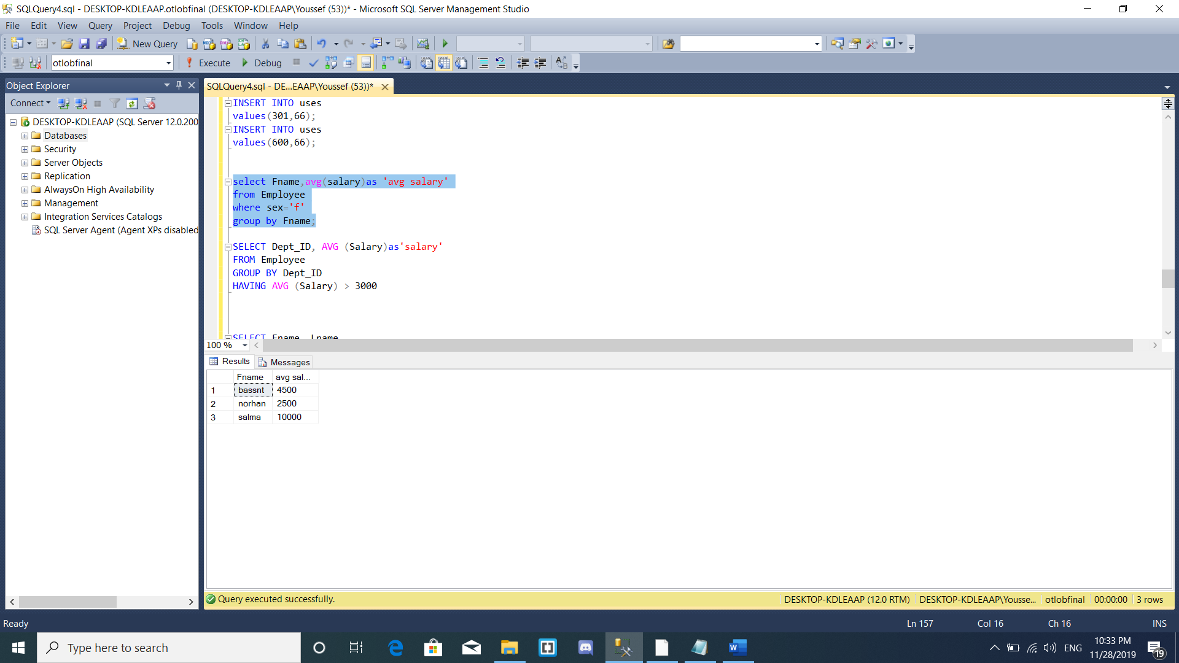

2.Retrieve the average salary and number of employees, grouped according to each department, but only retrieve the departments with average salary greater than 3000

SELECT Dept_ID, AVG (Salary)as'salary'

FROM Employee

GROUP BY Dept_ID

HAVING AVG (Salary) > 3000

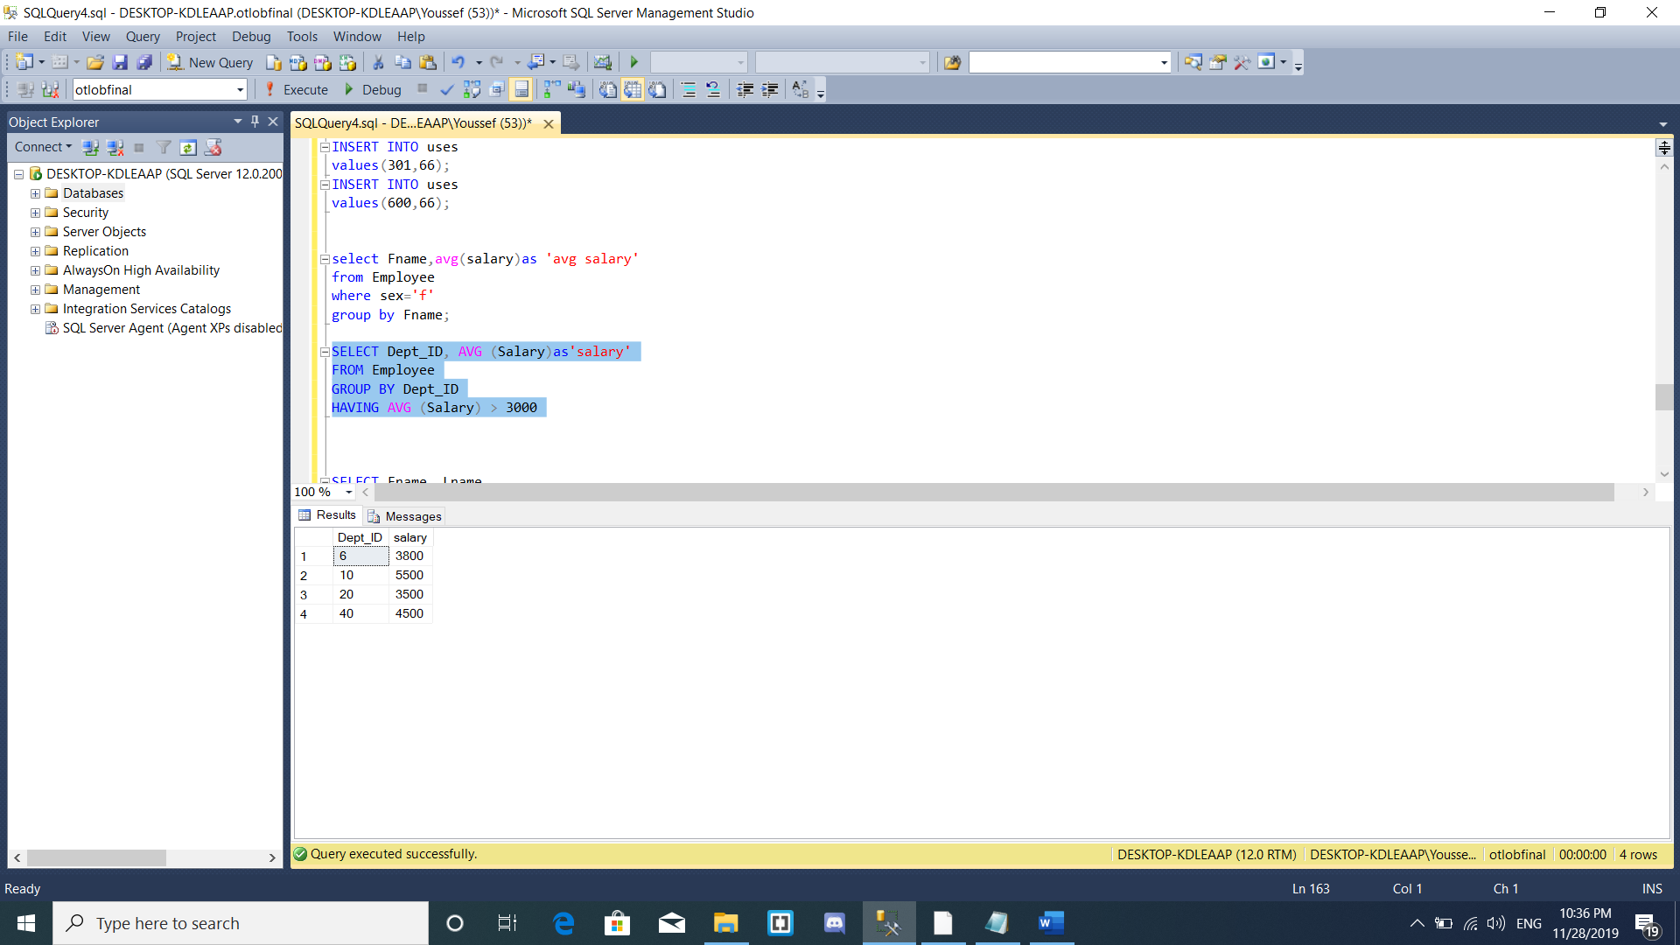

3. Retrieve the first and last names of the employees working in the IT department and are males

SELECT Fname, Lname

FROM Employee JOIN Department

ON Employee.Dept_ID=Department.Department_ID

WHERE Dname = 'IT'

AND Sex = 'm';

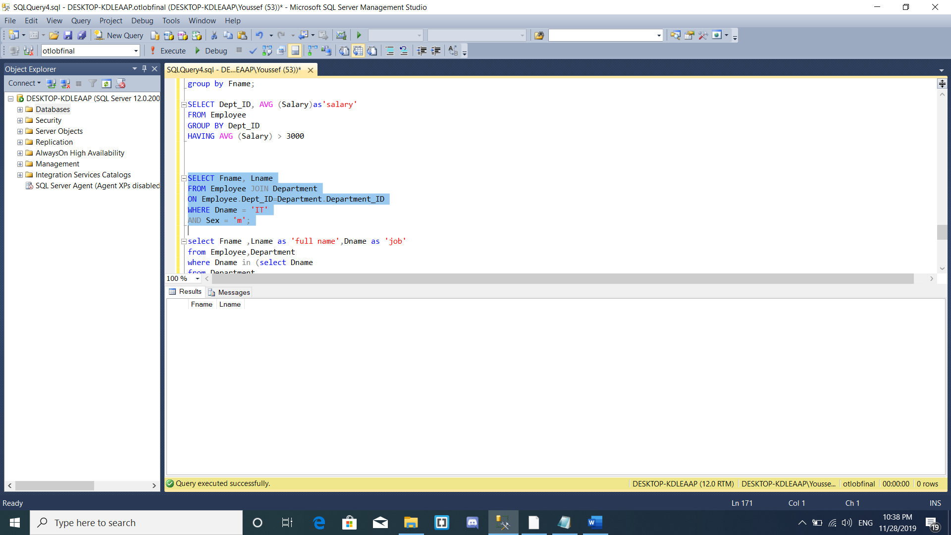

4. Retrieve the first and the last name for employee who works as a delivery.

select Fname ,Lname as 'full name',Dname as 'job'

from Employee,Department

where Dname in (select Dname

from Department

where Department_ID=Dept_ID

and Dname='delivery');

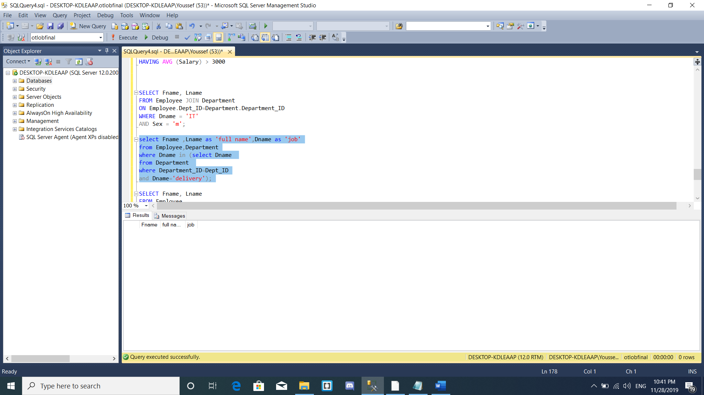

5. Retrieve the first and last names of department managers

SELECT Fname, Lname

FROM Employee

WHERE EXISTS (SELECT *

FROM Department

WHERE mgr_ssn = super_ssn);

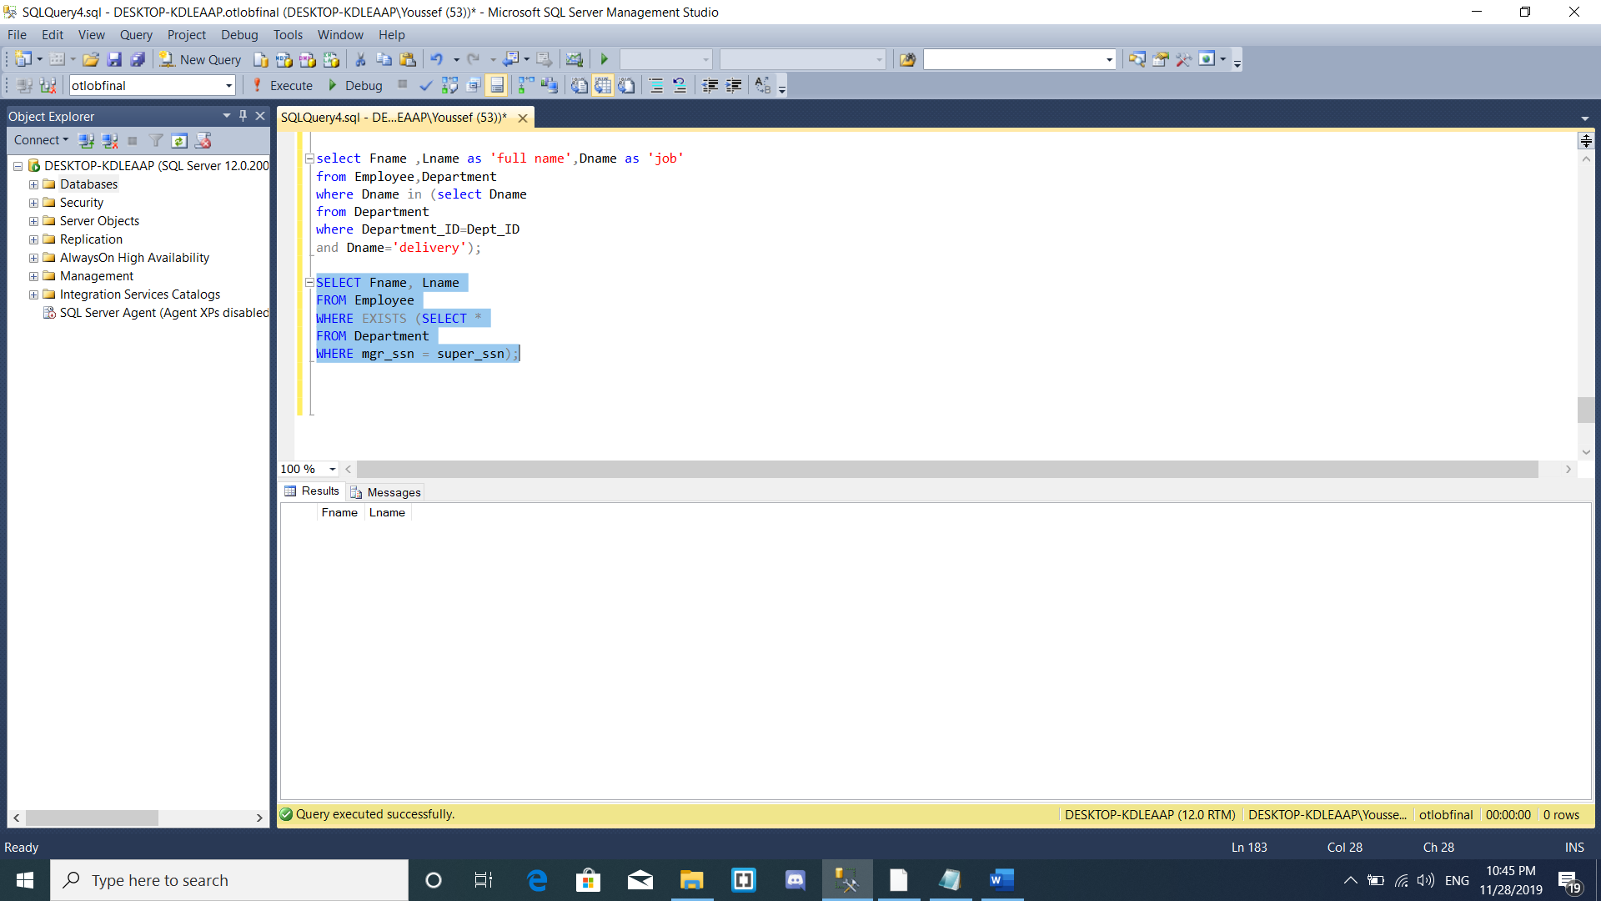

Abdulrhman zakria

**1st query retrieve the restaurant that is named by mac**

**2nd query retrieve the advertisement their type are gaming and motivational**

**3rd query return the address at 2 table where 2 address are the same**

**4th query left table is join with right table as customer id =order id**

**5th query count people live in shraton**

**6th query get the restaurant name where order id is less than 3**

**7th query is trigger query at customer table get the date of inserted data**

YousefAdel188743

Tables:Employee

Order

Restaurant

menu.

create database otlob2 ;

CREATE TABLE TRIG_audit(

food_ID int not null ,

food_type varchar (40),

food_name varchar (40),

paudit varchar (50),

CREATION date,

)

GO

CREATE TRIGGER TRIG

ON MENUU

FOR INSERT

AS

declare @food_ID int ;

declare @food_type varchar (40);

declare @food_name varchar (40);

declare @paudit varchar(50);

select @food_ID=i.food_ID from inserted i;

select @food_type=i.food_type from inserted i;

select @food_name=i.food_name from inserted i;

select @paudit ='insert trigger executed';

insert into TRIG_audit

values (@food_ID,@food_type,@food_name ,GETDATE());

print 'trigger successfully executed';

insert into MENUU

values(118,'fast food','Elbake');

create table EMPLOYEEE (

Fname varchar (30) not null,

Lname varchar (30) not null,

startDate varchar (30),

salary int ,

emp_ID int not null ,

emp_add varchar (50),

emp_sex varchar (10) not null,

constraint emp_pkk primary key (emp_ID),

);

insert into EMPLOYEEE(Fname,Lname,startDate,salary,emp_ID,emp_add,emp_sex)

values ('Yousef','Adel','2019',10000,123,'benha','male');

insert into EMPLOYEEE(Fname,Lname,startDate,salary,emp_ID,emp_add,emp_sex)

values ('Mostafa','Hossam','2019',10000,124,'Cairo','male');

insert into EMPLOYEEE(Fname,Lname,startDate,salary,emp_ID,emp_add,emp_sex)

values ('Omar','Mohmed','2019',12000,125,'cairo','male');

insert into EMPLOYEEE(Fname,Lname,startDate,salary,emp_ID,emp_add,emp_sex)

values ('Kareem','Abed','2019',13000,126,'Mansoura','male');

insert into EMPLOYEEE(Fname,Lname,startDate,salary,emp_ID,emp_add,emp_sex)

values ('Abdulrahman','Zakaria','2019',14000,127,'Cairo','male');

insert into EMPLOYEEE(Fname,Lname,startDate,salary,emp_ID,emp_add,emp_sex)

values ('Shehab','Hesham','2019',10000,128,'Cairo','male');

insert into EMPLOYEEE(Fname,Lname,startDate,salary,emp_ID,emp_add,emp_sex)

values ('Marawan','Hassan','2019',10000,129,'Cairo','male');

UPDATE EMPLOYEEE SET salary =11000 WHERE emp_ID =123;

UPDATE EMPLOYEEE SET salary =18000 wHERE emp_ID=126;

create table EmployeeAddress(

Employee_ID int not null ,

Street_name varchar (30),

Building_number int ,

Apartment_number int ,

Area varchar (40),

constraint Emp_Add_pkk primary key (Employee_ID,Building_number,Apartment_number),

constraint Emp_Add_fkk foreign key (Employee_ID) references EMPLOYEEE (emp_ID)

on update cascade

);

insert into EmployeeAddress (Employee_ID,Street_name,Building_number,Apartment_number,Area)

values (123,'Omar Ibn elkhattab st',15,2,null)

insert into EmployeeAddress (Employee_ID,Street_name,Building_number,Apartment_number,Area)

values (124,'Omar Ibn elkhattab st',15,3,null)

insert into EmployeeAddress (Employee_ID,Street_name,Building_number,Apartment_number,Area)

values (125,'Omar Ibn elkhattab st',15,4,null)

insert into EmployeeAddress (Employee_ID,Street_name,Building_number,Apartment_number,Area)

values (126,'naser st',16,5,null)

insert into EmployeeAddress (Employee_ID,Street_name,Building_number,Apartment_number,Area)

values (127,'ahmed st',17,6,null)

insert into EmployeeAddress (Employee_ID,Street_name,Building_number,Apartment_number,Area)

values (128,'mohmed st',18,7,null)

insert into EmployeeAddress (Employee_ID,Street_name,Building_number,Apartment_number,Area)

values (129,'ibrahem st',19,8,null)

create table RESTAURANTT(

restaurant_id int not null,

restaurant_name varchar (40) not null ,

restaurant_loc varchar (50) not null ,

constraint rest_pkk primary key (restaurant_id),

);

insert into RESTAURANTT(restaurant_id,restaurant_name,restaurant_loc)

values (100,' McDonald’s','Heliopolis');

insert into RESTAURANTT(restaurant_id,restaurant_name,restaurant_loc)

values (101,' Hadramout','Helwan');

insert into RESTAURANTT (restaurant_id,restaurant_name,restaurant_loc)

values (102,' Cheese House','Masr El Gedida');

insert into RESTAURANTT(restaurant_id,restaurant_name,restaurant_loc)

values (103,' Ramadan Grill','Nasr city');

insert into RESTAURANTT (restaurant_id,restaurant_name,restaurant_loc)

values (104,'Happy Cake','Zamalek');

insert into RESTAURANTT (restaurant_id,restaurant_name,restaurant_loc)

values (105,'Shader El Samak','Sheraton');

insert into RESTAURANTT (restaurant_id,restaurant_name,restaurant_loc)

values (106,'Sushi House','Zamalek');

create table "ORDERR"(

Destanation varchar (50) not null,

order_date varchar (40) not null,

order_ID int not null,

rest_id int ,

driver_id int,

constraint order_pkk primary key (order_ID),

constraint emp_order_fkk foreign key (driver_id) references EMPLOYEEE(emp_ID)

on update cascade,

constraint rest_order_fkk foreign key (rest_id) references RESTAURANTT(restaurant_id)

on update cascade,

);

insert into "ORDERR"(Destanation,order_date,order_ID,rest_id,driver_id)

values ('Sheraton','10/12/2019',111,100,123);

insert into "ORDERR"(Destanation,order_date,order_ID,rest_id,driver_id)

values ('Sheraton','10/5/2019',112,101,124);

insert into "ORDERR"(Destanation,order_date,order_ID,rest_id,driver_id)

values ('Zamalek','13/10/2019',113,102,125);

insert into "ORDERR"(Destanation,order_date,order_ID,rest_id,driver_id)

values ('Masr El Gedida','11/1/2019',114,103,126);

insert into "ORDERR"(Destanation,order_date,order_ID,rest_id,driver_id)

values ('Nasr city','10/2/2019',115,104,127);

insert into "ORDERR"(Destanation,order_date,order_ID,rest_id,driver_id)

values ('Heliopolis','1/12/2019',116,105,128);

insert into "ORDERR"(Destanation,order_date,order_ID,rest_id,driver_id)

values ('Helwan','11/12/2019',117,106,129);

create table MENUU(

food_ID int not null ,

food_type varchar (40),

food_name varchar (40),

RESTO_id int ,

constraint menu_pkk primary key (food_ID),

constraint rest_menu_fkk foreign key (RESTO_id) references RESTAURANTT(restaurant_id)

on update cascade,

);

insert into MENUU(food_ID,food_name,food_type,RESTO_id)

values (10,'Big Mac','Fast Food',101);

insert into MENUU(food_ID,food_name,food_type,RESTO_id)

values (20,null,'lunch',102);

insert into MENUU(food_ID,food_name,food_type,RESTO_id)

values (30,null,'Fast Food',103);

insert into MENUU(food_ID,food_name,food_type,RESTO_id)

values (40,null,'Diner',104);

insert into MENUU(food_ID,food_name,food_type,RESTO_id)

values (50,null,'lunch',105);

insert into MENUU(food_ID,food_name,food_type,RESTO_id)

values (60,null,'Fast Food',106);

insert into MENUU(food_ID,food_name,food_type,RESTO_id)

values (70,null,'Fast Food',107);

create table order_summary (

order_id int not null,

Quantity int not null,

items varchar(100) not null,

constraint order_sum_pk primary key (order_id ,Quantity,items) ,

constraint Summary_order_fk foreign key (order_id) references "ORDERR" (order_ID)

on update cascade,

);

insert into order_summary (order_id,Quantity,items)

values (111,2,'Hadramout')

insert into order_summary (order_id,Quantity,items)

values (112,5,'Cheese House')

insert into order_summary (order_id,Quantity,items)

values (113,4,'Shader El Samak')

insert into order_summary (order_id,Quantity,items)

values (114,7,'Happy Cake')

insert into order_summary (order_id,Quantity,items)

values (115,1,'Ramadan Grill')

insert into order_summary (order_id,Quantity,items)

values (116,8,'McDonald’s')

insert into order_summary (order_id,Quantity,items)

values (117,11,'Sushi House')

SELECT COUNT (*)

FROM EMPLOYEEE

WHERE Lname LIKE 'H%'

SELECT restaurant_name ,restaurant_loc

FROM RESTAURANTT left outer join MENUU on restaurant_id= RESTO_id

WHERE food_type='FAST FOOD'

SELECT Fname ,Lname

FROM EMPLOYEEE

WHERE salary< ALL (SELECT salary

FROM EMPLOYEEE

WHERE salary>10000);

SELECT DISTINCT (restaurant_name),Destanation

FROM ORDERR,RESTAURANTT

WHERE order_ID=111;

select *

from TRIG_audit

The query

1. Retrieve all the Employees which Last name starts with ‘H’

Letter

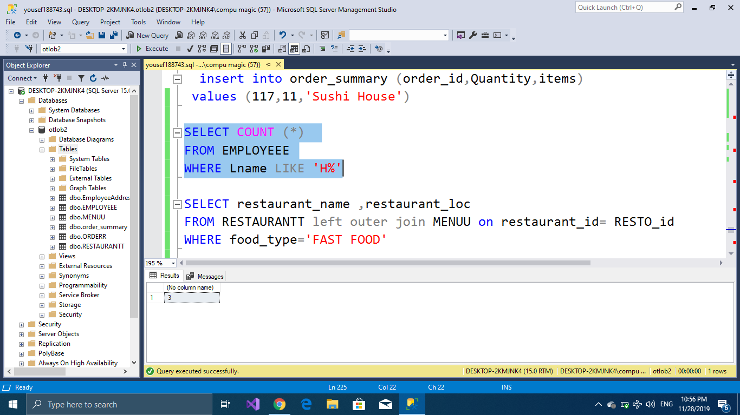

2.Retrive the restaurant name and location by make left outer join between menu and restaurant and give a condition which is the food type

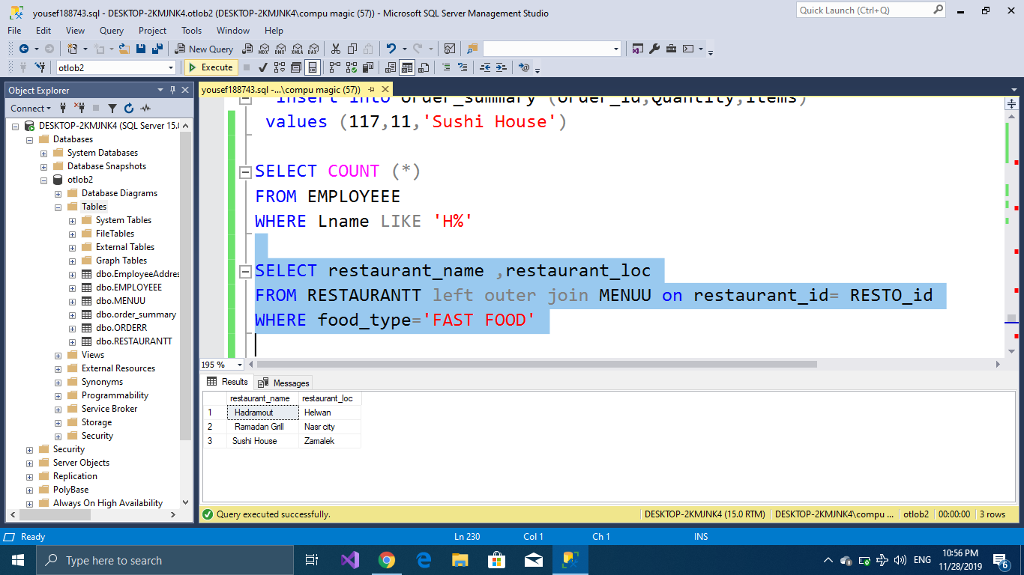

1. Retrieve the first name and the last name for the employee who’s salary more than 10000
2. 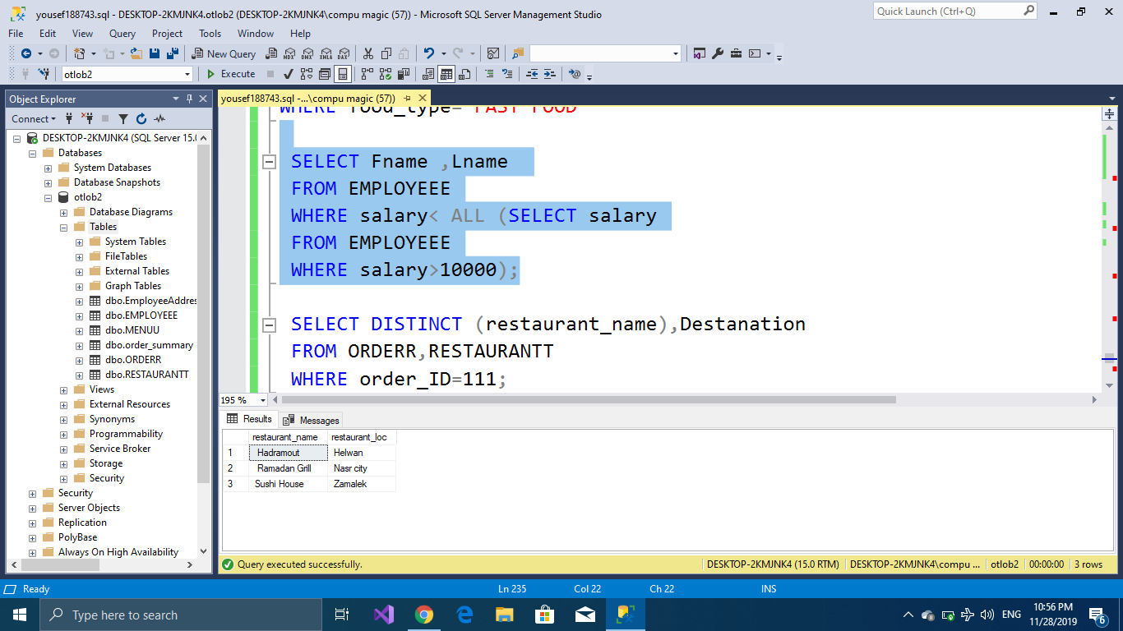
3. Retrieve the restaurant name and the order destination from the tables restaurant and order by giving condition the order id 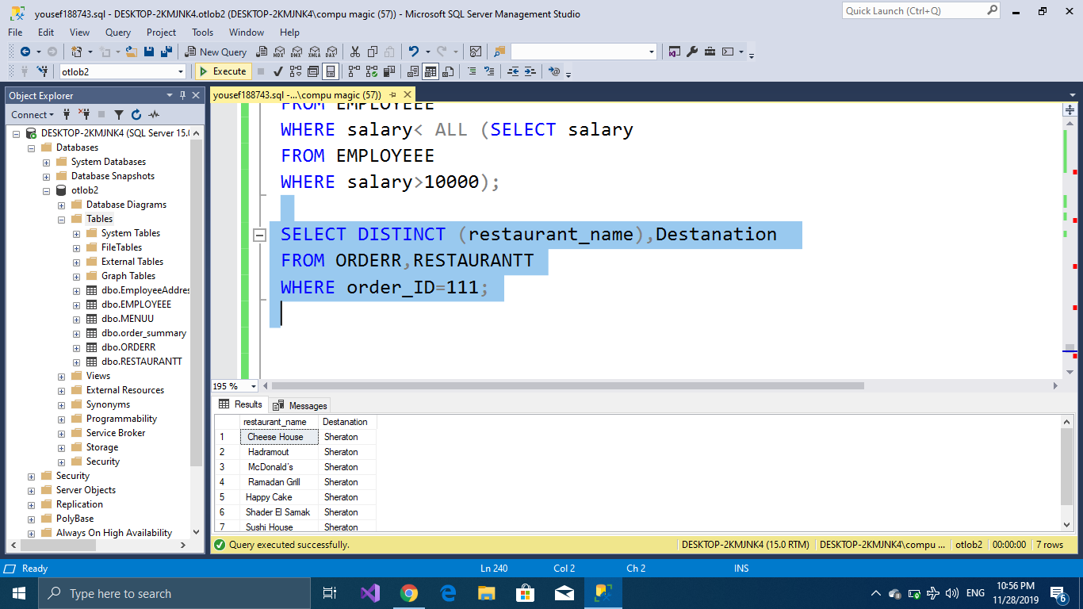

Omar Mohamed

CREATE DATABASE OlobFInalPhase190008;

CREATE TABLE Customer(

Fname VARCHAR(20) NOT NULL,

Lname VARCHAR(20),

Sex CHAR,

Customer_Id INT NOT NULL,

Phone_Number INT NOT NULL,

Customer_Mail VARCHAR(40) NOT NULL,

CONSTRAINT cust_pk PRIMARY KEY(Customer_Id)

);

CREATE TABLE Restaurant(

Rest_Name VARCHAR(20) NOT NULL,

Restaurant_Id INT NOT NULL,

Rest_Location VARCHAR(20),

CONSTRAINT rest_pk PRIMARY KEY(Restaurant_Id)

);

CREATE TABLE Orders(

Order_Id INT NOT NULL,

Order_Date Date,

Destination VARCHAR(20),

Rest_Id INT NOT NULL,

Cust_Id INT NOT NULL,

Driver_Id INT,

CONSTRAINT order_pk PRIMARY KEY(Order_Id),

CONSTRAINT cust_order

FOREIGN KEY(Cust_Id) REFERENCES Customer(Customer_Id)

ON UPDATE CASCADE,

CONSTRAINT rest_order

FOREIGN KEY(Rest_Id) REFERENCES Restaurant(Restaurant_Id)

ON UPDATE CASCADE,

);

CREATE TABLE Payment(

Payment_Id INT NOT NULL,

Payment_Date DATE,

Payment_Type VARCHAR(20),

Total_Cost INT,

Custp_Id INT NOT NULL,

CONSTRAINT p_pk PRIMARY KEY(Payment_Id),

CONSTRAINT cust_p

FOREIGN KEY(Custp_Id) REFERENCES Customer(Customer_Id)

ON UPDATE CASCADE

);

CREATE TABLE Customer_CreditCard(

CreditCard_Number INT NOT NULL,

CustId INT NOT NULL,

Exp_Date DATE NOT NULL,

CVV INT NOT NULL,

CONSTRAINT credit_pk PRIMARY KEY(CreditCard_Number,CustID),

CONSTRAINT credit_cust

FOREIGN KEY(CustId) REFERENCES Customer(Customer_Id)

ON UPDATE CASCADE

);

CREATE TABLE OrderSummary(

OrderId INT NOT NULL,

Quantity INT NOT NULL,

Items VARCHAR(15),

RestID INT NOT NULL,

CONSTRAINT sum_pk PRIMARY KEY(OrderId,Quantity,Items),

CONSTRAINT sum_order

FOREIGN KEY(OrderId) REFERENCES Orders(Order_Id)

ON UPDATE CASCADE

);

CREATE TABLE CustomerAddress(

CustomersId INT NOT NULL,

ApartmentNo INT NOT NULL,

BuldingNo INT NOT NULL,

StreetName VARCHAR(20) NOT NULL,

Area VARCHAR(20),

CONSTRAINT address_pk PRIMARY KEY(CustomersId,ApartmentNo,BuldingNo,StreetName),

CONSTRAINT address_fk FOREIGN KEY(CustomersId) REFERENCES Customer(Customer_Id)

ON UPDATE CASCADE

);

ALTER TABLE Orders

ALTER COLUMN Order_Date VARCHAR(10);

ALTER TABLE Payment

ALTER COLUMN Payment_Date VARCHAR(10);

ALTER TABLE Customer_CreditCard

ALTER COLUMN Exp_Date VARCHAR(10);

ALTER TABLE OrderSummary

DROP COLUMN RestID;

INSERT INTO Customer(Fname,Lname,Sex,Customer_Id,Phone_Number,Customer_Mail)

VALUES('Ahmed','Abas','M','1','0154535','ahmed@gmail.com');

INSERT INTO Customer

VALUES('Mona','hesham','F','2','01232535','mona@bue.edu.eg');

INSERT INTO Customer

VALUES('Israa','osama','F','3','01848929','israa@gmail.com');

INSERT INTO Customer

VALUES('Noor','Bassem',NULL,'4','019000304','noor@yahoo.com');

INSERT INTO Customer

VALUES('Mohamed',NULL,'M','5','01003947522','moh@bue.edu.eg');

INSERT INTO Customer

VALUES('Abdulrahman','yousef','M','6','0199998324','abdo@yahoo.com');

INSERT INTO Customer

VALUES('Sara',' ','F','7','0920348294','sara@bue.edu.eg');

UPDATE Customer

SET Lname='Ahmed'

WHERE Customer_Id=7;

INSERT INTO Restaurant(Rest_Name,Restaurant_Id,Rest_Location)

VALUES('Buffalo','01','New Cairo');

INSERT INTO Restaurant

VALUES('Pizza Hut','02','ALRehab');

INSERT INTO Restaurant

VALUES('City Crepe','03','Al maadi');

INSERT INTO Restaurant

VALUES('Cinnabon','04',NULL);

INSERT INTO Restaurant

VALUES('KFC','05','Nasr City');

INSERT INTO Restaurant

VALUES('MAC','06','Nasr City');

INSERT INTO Restaurant

VALUES('Heart attack','07','Madinaty');

INSERT INTO Orders(Order_Id,Order_Date,Destination,Rest_Id,Cust_Id,Driver_Id)

VALUES('101','14/2/2019','AlRehab','05','7',NUll);

INSERT INTO Orders

VALUES('102','25/10/2019','New Cairo','02','2',NULL);

INSERT INTO Orders

VALUES('103','6/3/2018','Nasr City','06','7','92');

INSERT INTO Orders

VALUES('104','22/9/2018','Nasr City','07','6','92');

INSERT INTO Orders

VALUES('105','22/6/2019','Nasr city','04','7','93');

INSERT INTO Orders

VALUES('106','30/11/2017','Al maadi','03','1','94');

INSERT INTO Orders

VALUES('107','9/1/2017','Nasr City','05','4','92');

UPDATE Orders

SET Cust_Id=7

WHERE Order_Id=101;

UPDATE Orders

SET Cust_Id=2

WHERE Order_Id=102;

UPDATE Orders

SET Destination='Madinaty'

WHERE Order_Id=102;

UPDATE Orders

SET Destination='Ramsis'

WHERE Order_Id=107;

INSERT INTO Payment(Payment_Id,Payment_Date,Payment_Type,Total_Cost,Custp_Id)

VALUES ('1001','10/10/2019','Credit Card','150','7');

INSERT INTO Payment

VALUES ('1002','7/6/2019','Credit Card','180','5');

INSERT INTO Payment

VALUES ('1003','27/3/2019','Cash','90','3');

INSERT INTO Payment

VALUES ('1004','25/4/2018',NULL,'80','6');

INSERT INTO Payment

VALUES ('1005','24/3/2018','Cash','130','7');

INSERT INTO Payment

VALUES ('1006','7/7/2017','Credit Card','75','1');

INSERT INTO Payment

VALUES ('1007','15/12/2017','Cash',' ','4');

INSERT INTO Customer_CreditCard(CreditCard_Number,CustId,Exp_Date,CVV)

VALUES ('3505120','5','10/10/2021','324');

INSERT INTO Customer_CreditCard

VALUES ('3505004','7','15/8/2020','569');

INSERT INTO Customer_CreditCard

VALUES ('35505778','7','17/9/2021','409');

INSERT INTO Customer_CreditCard

VALUES ('35055055','1','5/2/2020','322');

INSERT INTO Customer_CreditCard

VALUES ('3501239','6','22/7/2022','179');

INSERT INTO Customer_CreditCard

VALUES ('35550382','6','17/6/2020','891');

INSERT INTO Customer_CreditCard

VALUES ('34440911','1','9/1/2021','423');

INSERT INTO OrderSummary(OrderId,Quantity,Items)

VALUES ('103','5','Big Mac')

INSERT INTO OrderSummary

VALUES ('106','3','Crepe');

INSERT INTO OrderSummary

VALUES ('107','2','Rizo');

INSERT INTO OrderSummary

VALUES ('104','4','Burgers');

INSERT INTO OrderSummary

VALUES ('101','4','Twister');

INSERT INTO OrderSummary

VALUES ('105','2','Cinnabon');

INSERT INTO OrderSummary

VALUES ('102','1','Pizza');

UPDATE OrderSummary

SET Items='Burgers'

WHERE OrderId=103;

INSERT INTO CustomerAddress(CustomersId,ApartmentNo,BuldingNo,StreetName,Area)

VALUES('1','03','25','9 St','Al maadi');

INSERT INTO CustomerAddress

VALUES('2','10','26','ElWaha St','Madinaty');

INSERT INTO CustomerAddress

VALUES('7','04','27','ELkhattab St','AlRehab');

INSERT INTO CustomerAddress

VALUES('4','08','28','Ramsis St',NUll);

INSERT INTO CustomerAddress

VALUES('5','07','29','Abass St','Nasr City');

INSERT INTO CustomerAddress

VALUES('6','09','30','Makram St','Nasr City');

INSERT INTO CustomerAddress

VALUES('7','04','25','Makram St','Nasr City');

SELECT DISTINCT Fname as 'First Name'

FROM Customer,CustomerAddress,Restaurant,Orders

WHERE Customer_Id IN (SELECT CustomersId

FROM CustomerAddress

WHERE Area='Nasr City')

AND Restaurant_Id IN(SELECT Rest_Id

FROM Orders,Restaurant

WHERE Destination='Nasr City')

AND Restaurant_Id IN (SELECT Rest_Id

FROM Restaurant,Orders

WHERE Rest_Location='Nasr City')

SELECT Lname as 'Last name', Payment_Type As 'Payment Type'

FROM Customer RIGHT OUTER JOIN Payment

ON Customer_Id=Custp_Id

WHERE Sex!='F' AND

Payment_Type!='Cash';

SELECT DISTINCT Order_Date as 'Date of order', Order_Id

FROM Orders

WHERE Order_Id IN( SELECT OrderId

FROM OrderSummary

WHERE Items='Burgers')

SELECT COUNT(*) as 'Num of orders', Order_Id

FROM Orders

WHERE Cust_Id IN ( SELECT Customer_Id

FROM Customer

WHERE Fname='Sara')

GROUP BY Order_Id

SELECT Fname as 'Name of Customers'

FROM Customer

WHERE Customer_Id IN (SELECT Cust_Id

FROM Orders

WHERE Driver_Id='92')